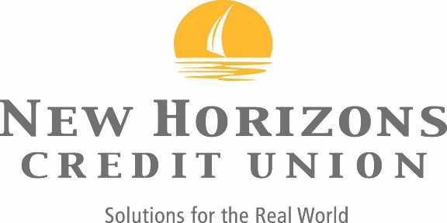

REGULATION D

As a financial institution, New Horizons Credit Union must comply with and enforce numerous federal regulations. One of these regulations, known as Regulation D, limits you to no more than six (6) withdrawals or transfers from each share savings and money market account during the calendar month.
Regulation D transactions include withdrawals and transfers to another account of yours or to a third party by Voice 24 Telephone Access, Online Banking, overdraft protection transfers, transfers done over the phone with one of our Member Services Center Representatives, ACH withdrawals and preauthorized debits.
There is no limit to transfers or withdrawals done in person, or through an ATM.

